Lesson 6: Designing Effective and Visually Appealing Dashboards
a) Apply worksheet-level and workbook-level formatting
b) Customize number, date, and null value formatting
c) Design effective color schemes and layouts
d) Create informative tooltips
e) Implement “Viz in Tooltip”
f) Improve readability and user experience
g) Apply best practices for visual storytelling decide dataset after seeing tis questions

A: Apply Worksheet-Level and Workbook-Level Formatting
Worksheet and workbook formatting establish visual hierarchy, readability, and a polished design across all views in your Tableau workbook.
Task 1: Connect to the Dataset and Build a Baseline Chart
1. Connect Data in Tableau: o Open Tableau Desktop.
- on the left blue panel under To a File, click Text File.
- Browse to the folder where you extracted the files, select List of Orders.csv, and click Open. Similarly open Order Details.csv
2. Relate the Two Files:
- In the top left under Files, drag Order Details.csv into the canvas area (to the right of List of Orders.csv).
- A line (noodle) will connect them. If a popup asks for the relationship field, select Order ID from List of Orders on the left and Order ID from Order Details on the right (Tableau May have Selected it By Default as marked in the snapshot after dropping the Order Details.csv in canvas area).
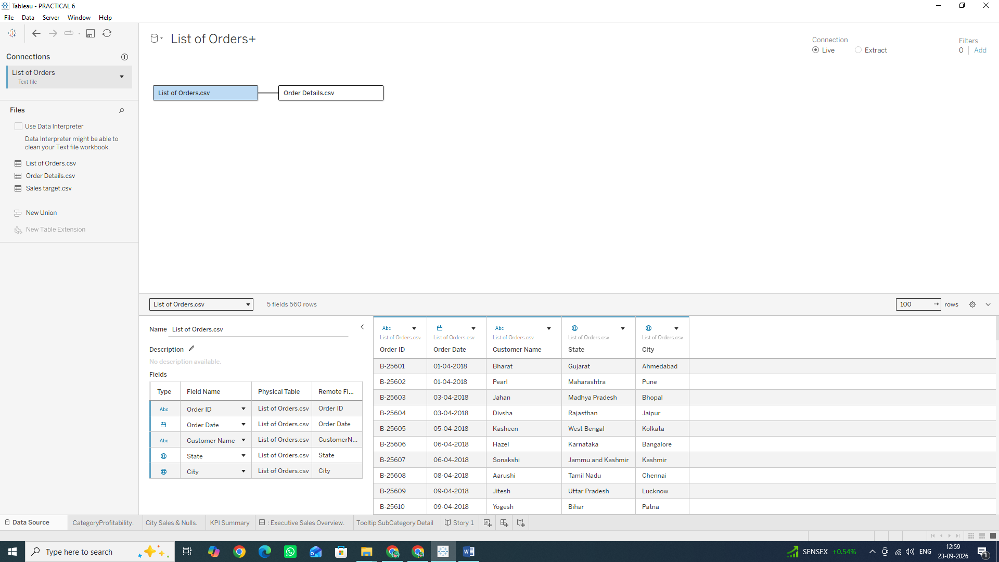
3. Create the Base Chart:
- At the bottom left, click on Sheet 1.
- Right-click the Sheet 1 tab at the bottom, select Rename, and type: Category Profitability.
- From the Data Pane on the far left, click and drag Category onto the Rows shelf (at the top of the screen).
- From the Data Pane, click and drag Profit onto the Columns shelf.
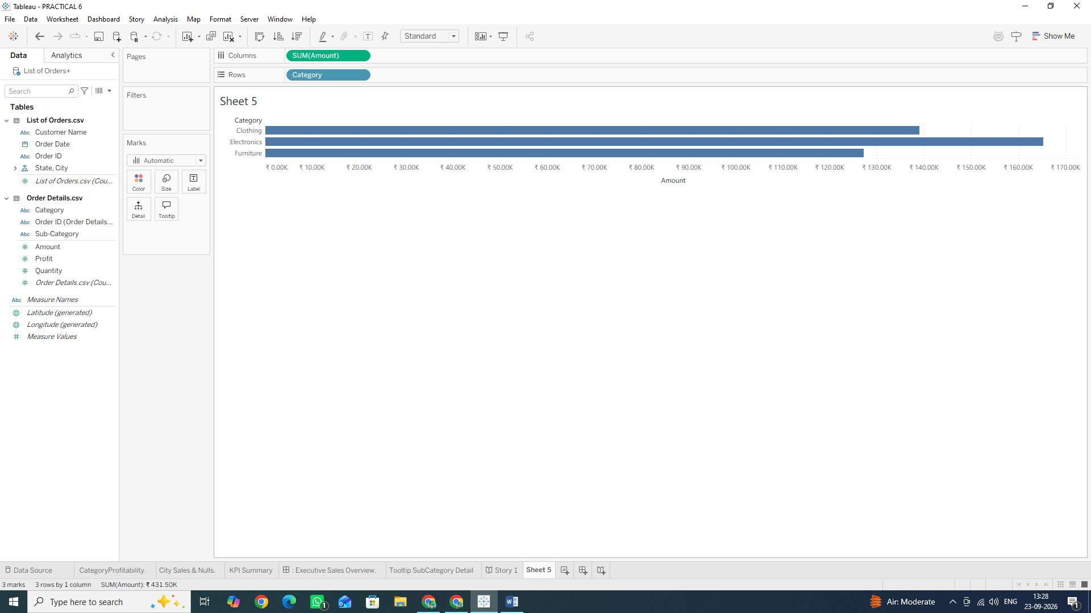

Task 2: Apply Workbook-Level Formatting
Workbook-level changes update the font, style, and grid lines across all current and future sheets in this entire workbook at once.
1. Go to the top menu bar, click Format, then select Workbook...
2. A Format Workbook panel will open on the left side of your screen:
- Fonts: Under Fonts, click the drop-down menu for Workbook Fonts and select Segoe UI (or Tableau Book).
- Title Font: Click the drop-down under Worksheet Titles and set the font to Segoe UI Semibold, size 14pt, and select a dark gray or navy color.
- Grid Lines: Scroll down to the Lines section in the panel. Click the drop-down next to Grid Lines and select Off (or choose a light gray line).
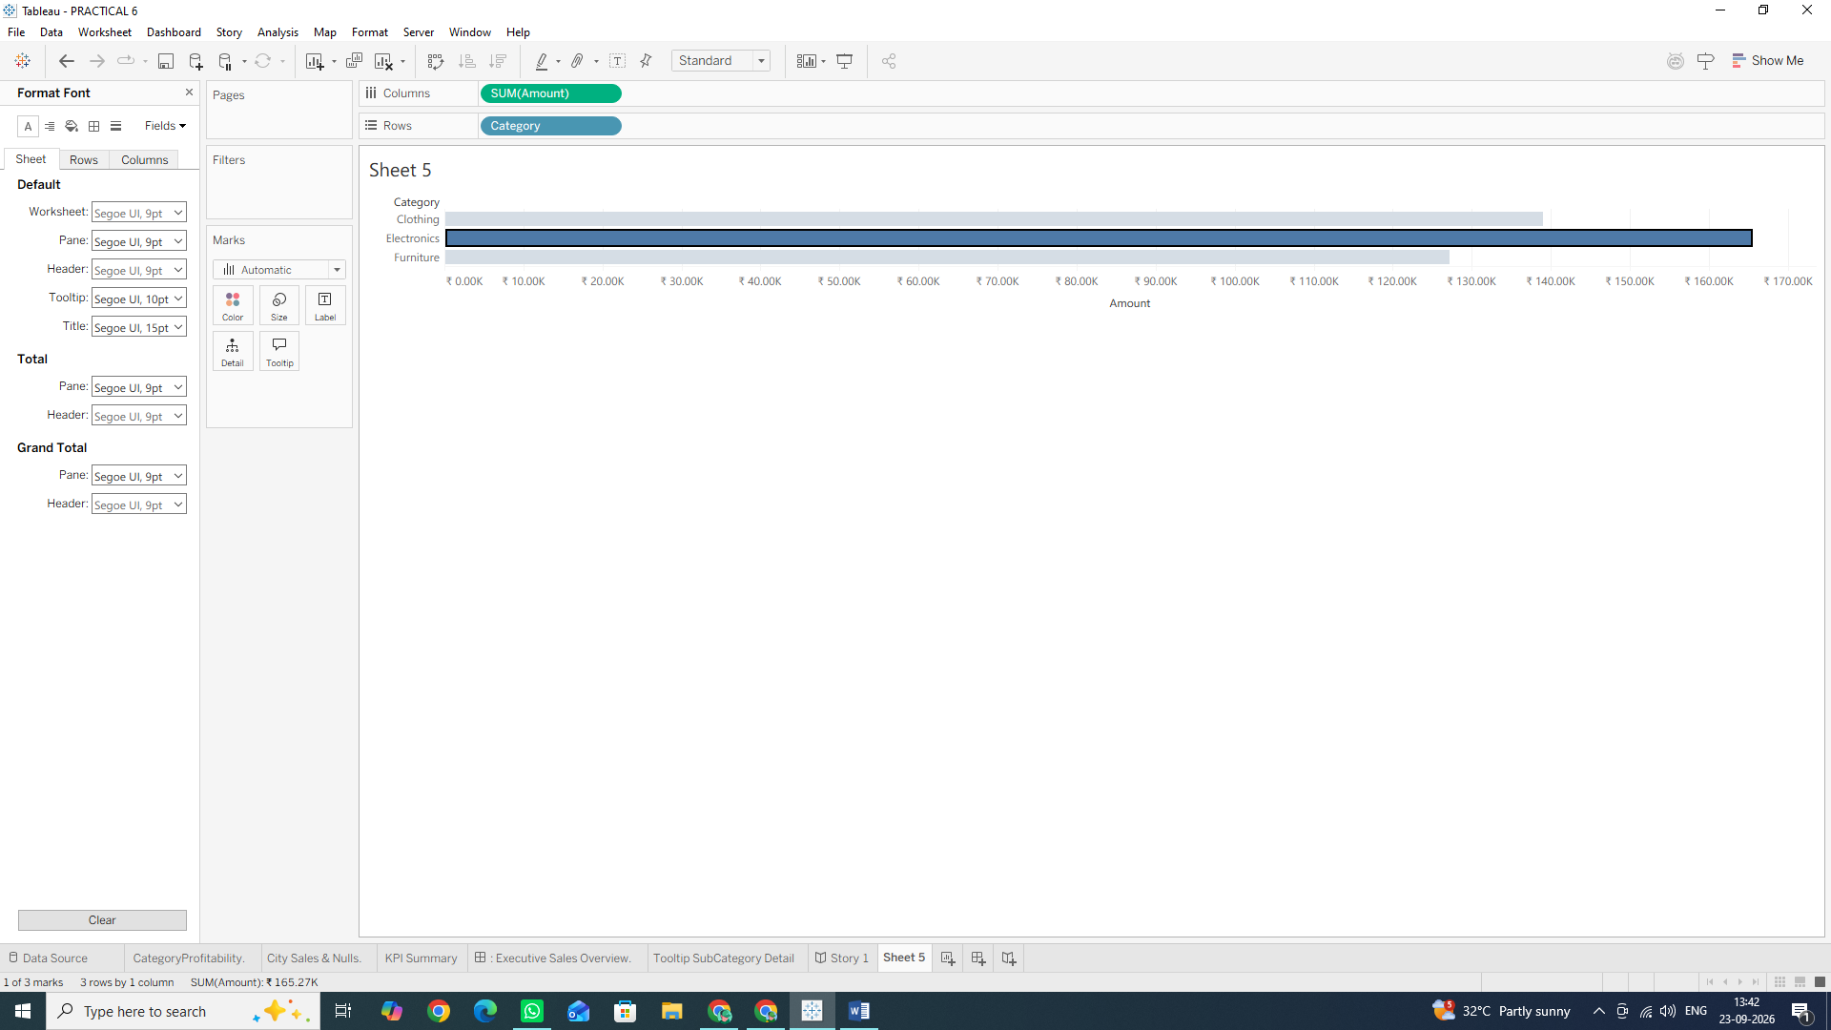
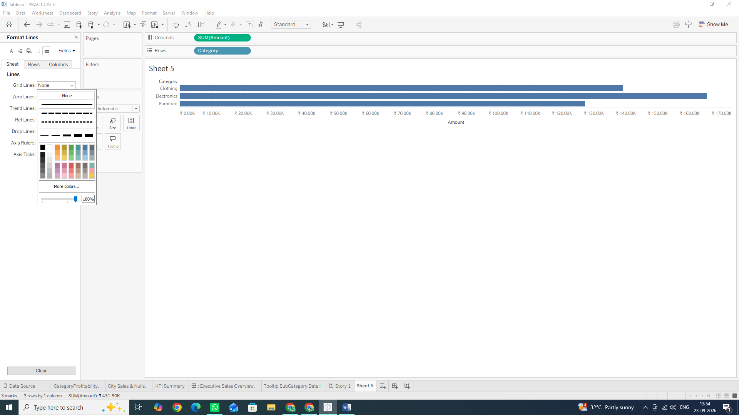
3. Click the small X at the top right of the Format panel to close it.
Task 3: Apply Worksheet-Level Formatting
Worksheet-level formatting applies specific styling to the currently active sheet only.
1. Right-click anywhere on the blank area of your bar chart and select Format... or Click Format in Menu Bar (This opens the Format pane on the left).
2. Format Text/Fonts:
- At the top of the Format pane, click the Font tab (it looks like a capital A)
- Under Header, click the drop-down menu, set the font style to Bold, and size to 10pt
- Under Pane, set the font style to Regular and size to 10pt.

3. Format Borders:
- At the top of the Format pane, click the Borders tab (it looks like a square outline with four quadrants).
- Under Row Divider, click the Pane drop-down and select None (TABLEAU may Have selected it by default)
- Under Column Divider, click the Pane drop-down and select None. (This removes boxy border lines around your bars).
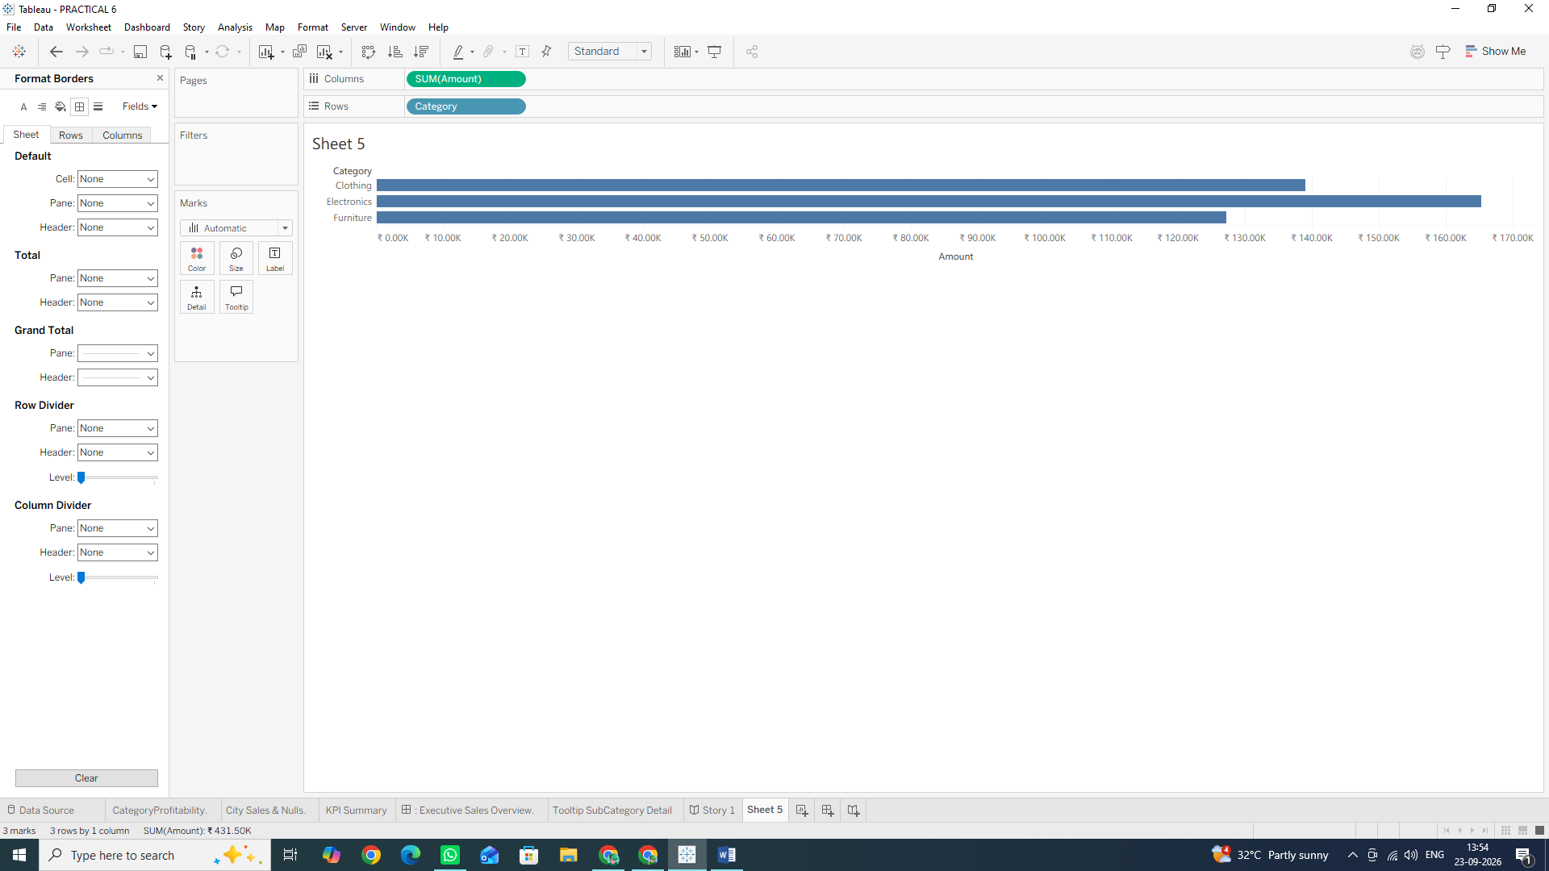

4. Format Zero Lines:
- At the top of the Format pane, click the Lines tab (it looks like a small line/axis icon).
- Find the Zero Lines option, click its drop-down, and select a solid dark gray line. (This makes the zero-boundary line distinct, clearly separating positive profit from losses).
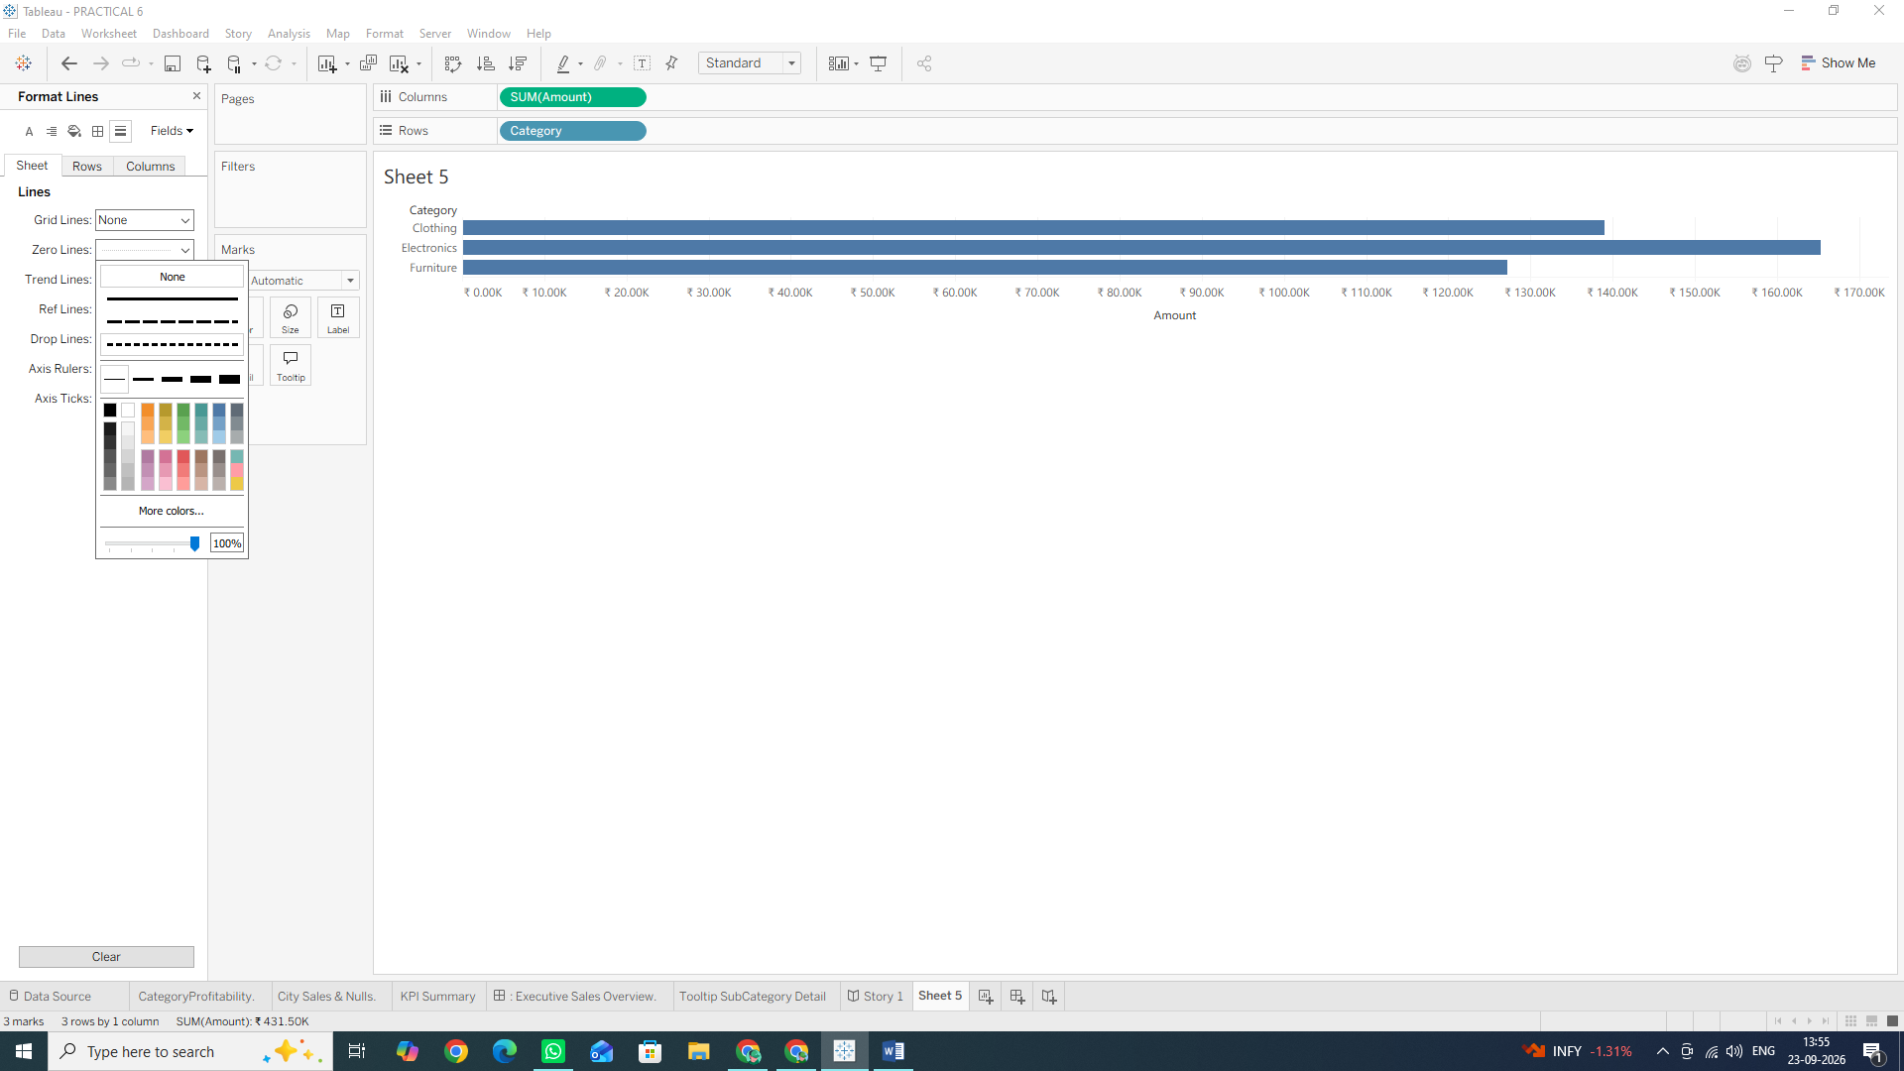

- Workbook Formatting: Controls overall visual standards so you don't have to manually format every single sheet one by one.
- Worksheet Formatting: Removing unnecessary border lines and grid lines reduces visual clutter ("chart junk"), making your chart immediately scannable and executive-ready.

B: Customize Number, Date, and Null Value Formatting
Default formats in Tableau often show unformatted numbers, raw dates, or blank spaces for nulls. In this section, you will learn how to customize currency formats, standardize date display, and clean up null values.
Task 1: Format Profit and Amount as Indian Currency (INR / ₹)
1. In the Data Pane on the left side of your screen, find Profit under Order Details.
2. Right-click Profit, hover over Default Properties, and click Number Format...
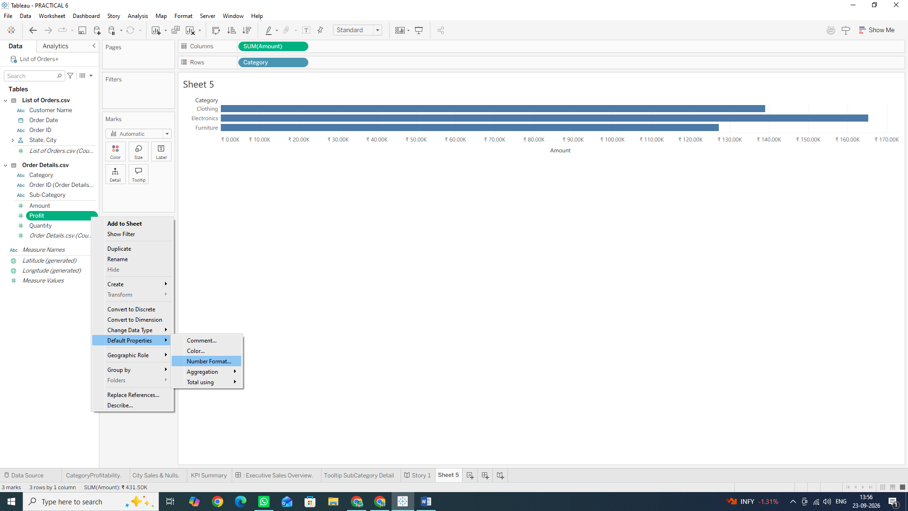
3. In the dialog box that opens:
- Select Currency (Custom) on the left menu.
- Set Decimal places to 0 (or 2 if you prefer decimals).
- Set Prefix/Suffix: Type ₹ into the Prefix box (or INR).
- Set Display Units to Thousands (K) or Thousands (K) depending on preference (or leave as None).
1. Click OK.
2. Repeat these steps for the Amount field:
- Right-click Amount -> Default Properties -> Number Format...
- Choose Currency (Custom), set Prefix to ₹, and click OK.
- Result: Every time you drag Profit or Amount onto any view, it will automatically render formatted with the rupee symbol.

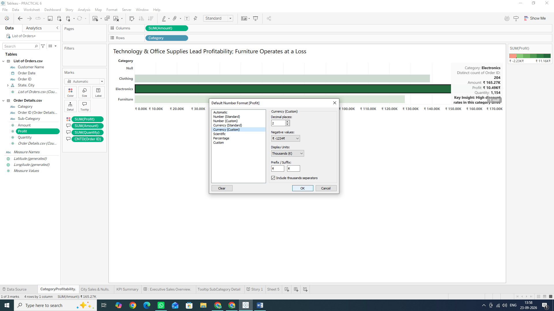
Task 2: Standardize Date Formatting
1. In the Data Pane, locate Order Date under List of Orders.
2. Right-click Order Date, hover over Default Properties, and click Date Format...
3. In the menu:
- Select a standard format like dd-mmm-yyyy (e.g., 14-Jan-2018) or scroll down to select Custom and type: dd-MMM-yyyy.
4. Click OK. 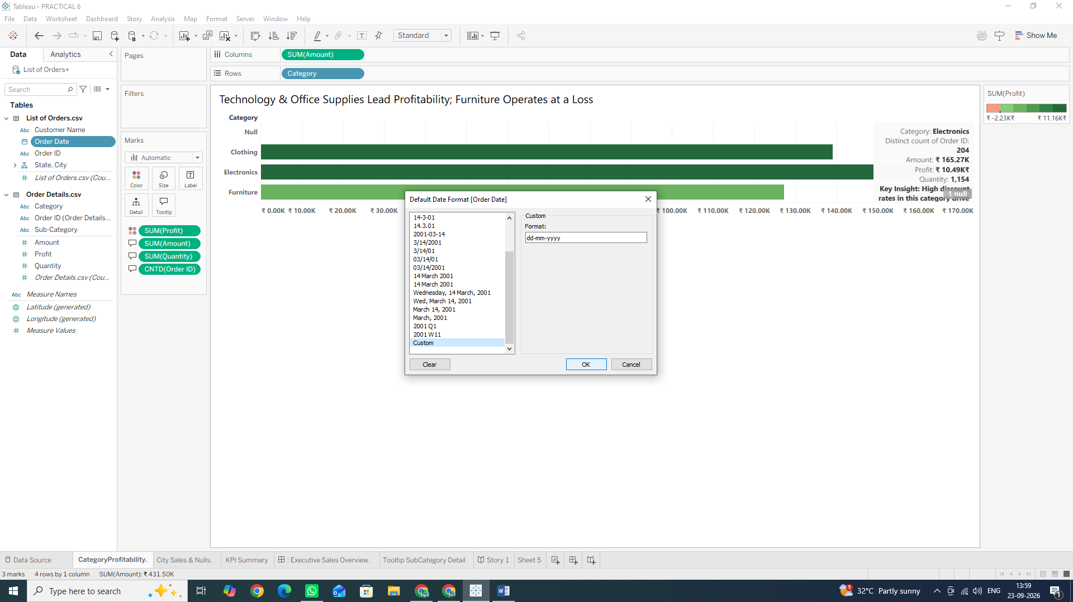
Task 3: Handle and Custom-Format Null Values
1. Create a new worksheet by clicking the New Worksheet tab at the bottom and name it: City Sales & Nulls.
2. From the Data Pane, drag State to the Rows shelf.
3. Drag City to the Rows shelf (placing it next to State).
4. Drag Amount to the Columns shelf.
5. Notice if any rows contain blank cells or say Null.
6. Customize Null Text:
- Right-click on the SUM(Amount) pill on the Columns shelf and select Format...
- In the Format pane on the left, make sure you are on the Pane tab.
- At the very bottom of the Format pane, find the Special Values (e.g. NULL) section.
- In the Text box, type: Not Reported or N/A.
- In the Marks drop-down, you can choose Hide (Break Lines) or Show at Default Value.
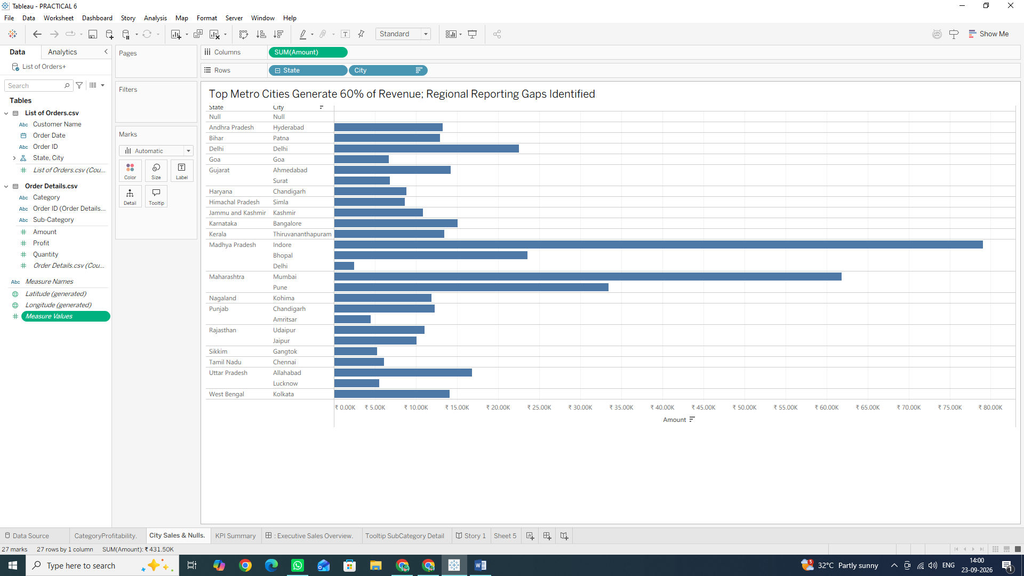
Why We Are Doing It?
- Default Properties: Setting default number and date formats at the field level saves time so you don't have to manually format measures on every single worksheet.
- Handling Special Values: Replacing generic Null labels with meaningful text like N/A or Not Reported provides clarity for business stakeholders and keeps dashboard visuals polished.
C: Design Effective Color Schemes and Layouts
Colour choice and layout structure guide the user’s attention. Using excessive colors creates distraction, while purposeful colour choices, such as highlighting profitability or using diverging colour palettes, instantly communicate business performance.
Task 1: Apply a Diverging Colour Scheme for Profitability
1. Click on your Category Profitability worksheet tab at the bottom.
2. From the Data Pane on the left, drag Profit directly onto the Color card in the Marks card.
3. Tableau will assign a default color gradient. To customize it:
- Click the Color card on the Marks card.
- Click Edit Colors... 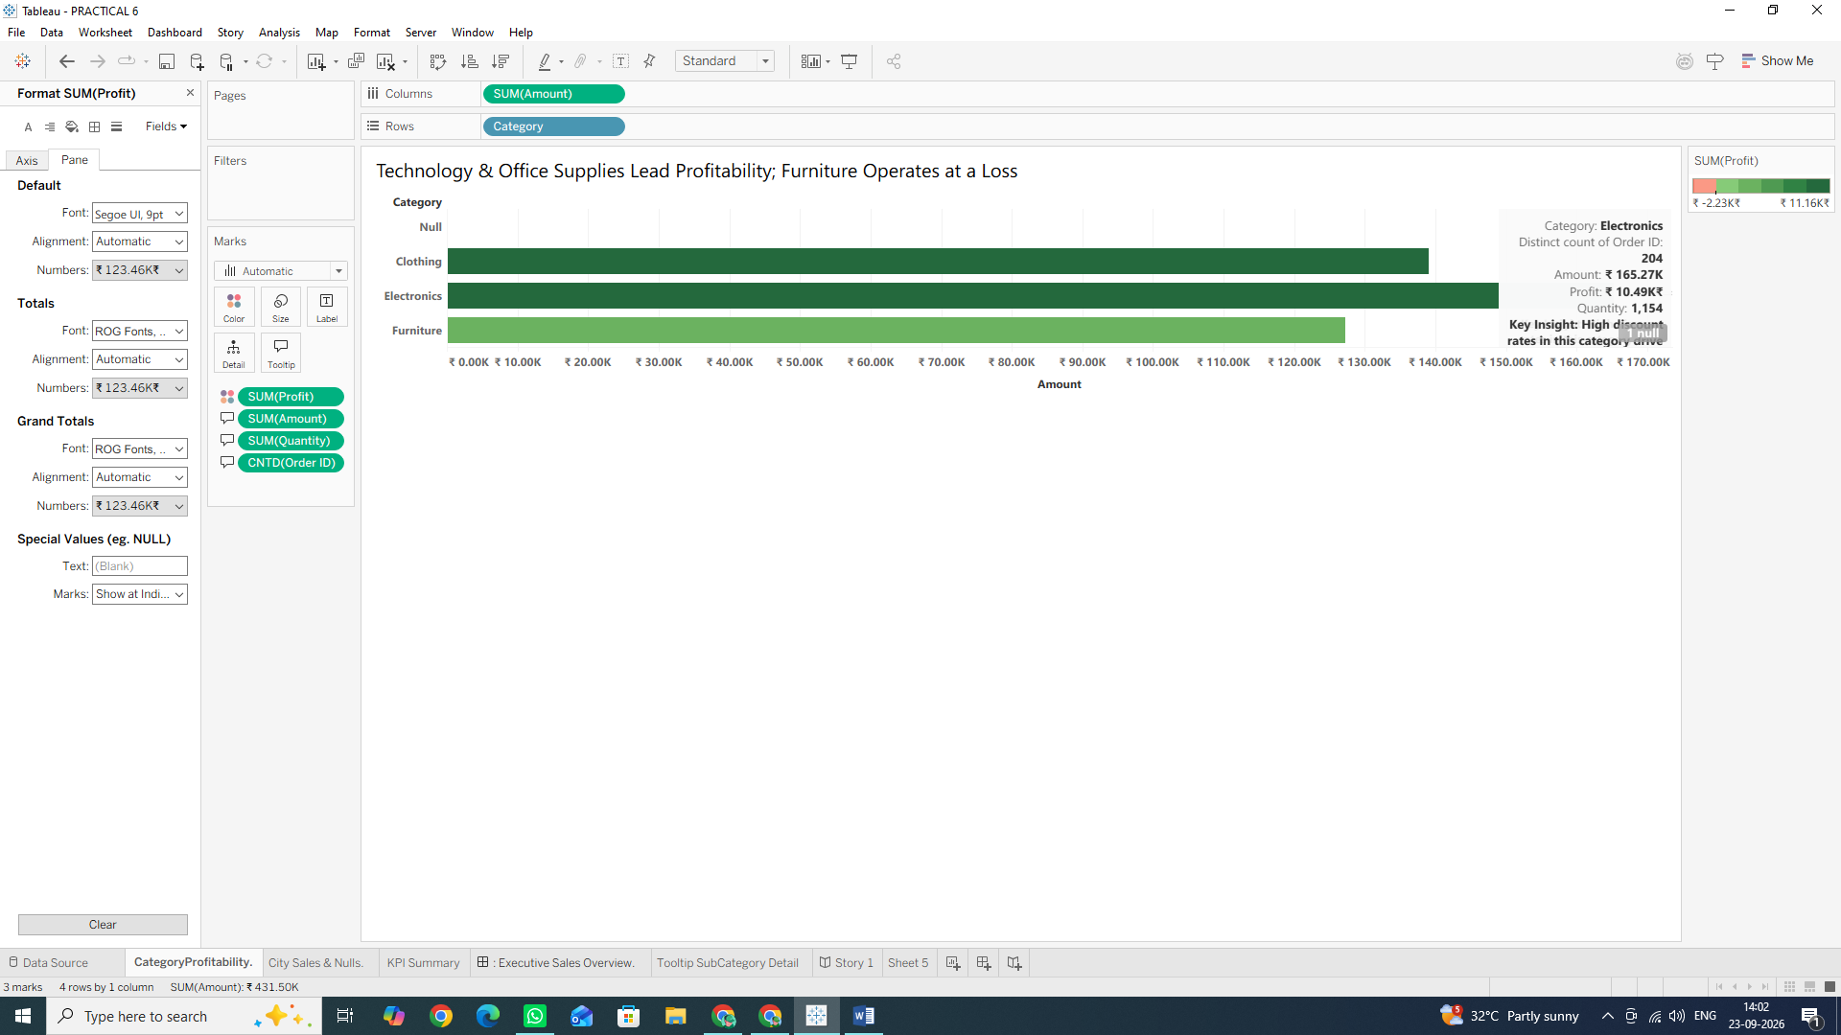

4. In the Edit Colors dialog box:
- Click the Palette drop-down menu and select Orange-Blue Diverging (or Red Green Diverging).
- Check the box for Stepped Color and set the number of steps to 4 or 6 (this creates clear, distinct color bands).
- Click Advanced >> to expand additional settings (The Additional settings may show even if you don’t click advanced).
- Check the Center box and ensure the value is set to 0. (This guarantees that negative profit values show as orange/red and positive values show as blue/green, with zero as the clear neutral midpoint).
5. Click Apply, then click OK.
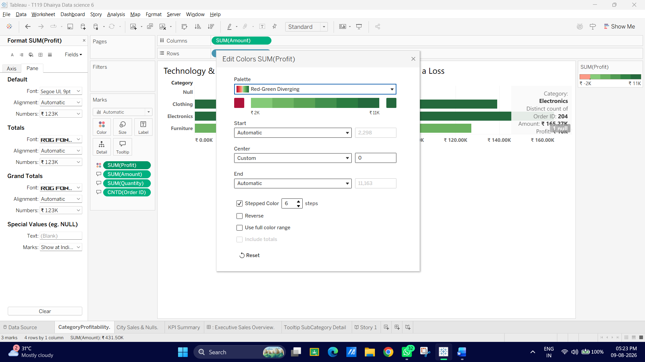
Task 2: Build a Clean KPI Summary Sheet (Card Layout)
1. Click the New Worksheet icon at the bottom and name it: KPI Summary.
2. Change the Mark type in the Marks card drop-down from Automatic to Text.
3. Drag Amount onto the Text card (it will display as SUM(Amount)).
4. Drag Profit onto the Text card (it will display as SUM(Profit)).
5. Drag Order ID onto the Text card.
- Click the down arrow on the Order ID pill -> Measure
- Count (Distinct) so it displays as CNTD (Order ID).

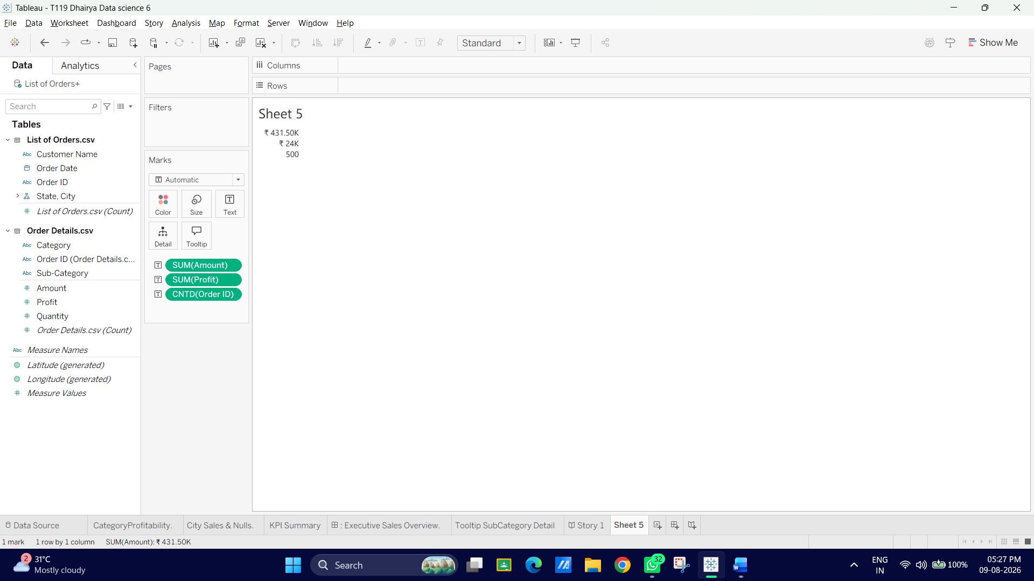
6. Click the Text card on the Marks card, then click the ... button next to Text to edit the text layout:
- Arrange and format the text clearly:
- TOTAL SALES <SUM(Amount)> TOTAL PROFIT <SUM(Profit)> TOTAL ORDERS <CNTD (Order ID)>
- Highlight the metric values (<SUM(Amount)>, etc.), make them Bold and siz18pt.
- Highlight the labels (TOTAL SALES, etc.), make them light gray, Bold, and size 9pt.
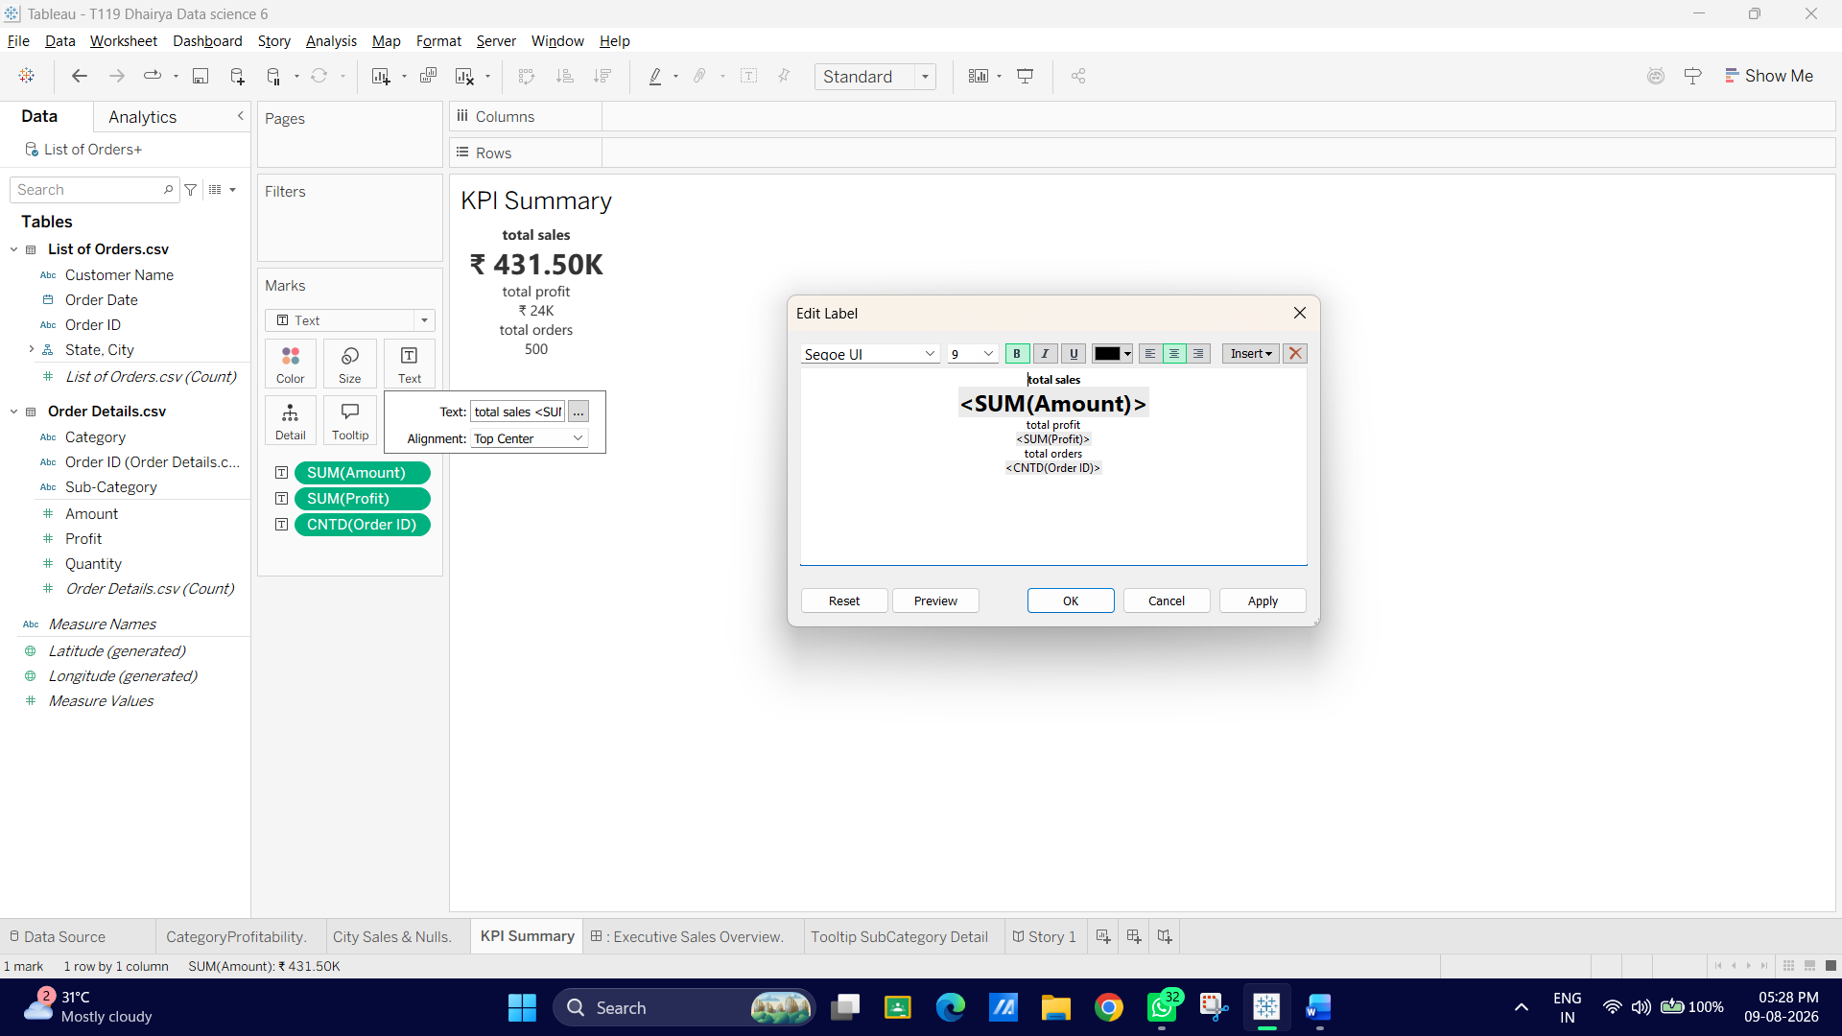
7. Click OK.
8. Right-click anywhere in the sheet background, select Format..., go to the Alignment tab (icon with text lines), and set Horizontal Alignment to Center.
Note: The Alignment is not changing by the given steps
Click the square button labeled Text (it has a 'T' icon on it and sits right next to the Color and Size buttons).
A menu will drop down. Look for the Alignment section in this menu, click the dropdown next to it, and select the Center icon (the middle set of lines) for the Horizontal alignment.
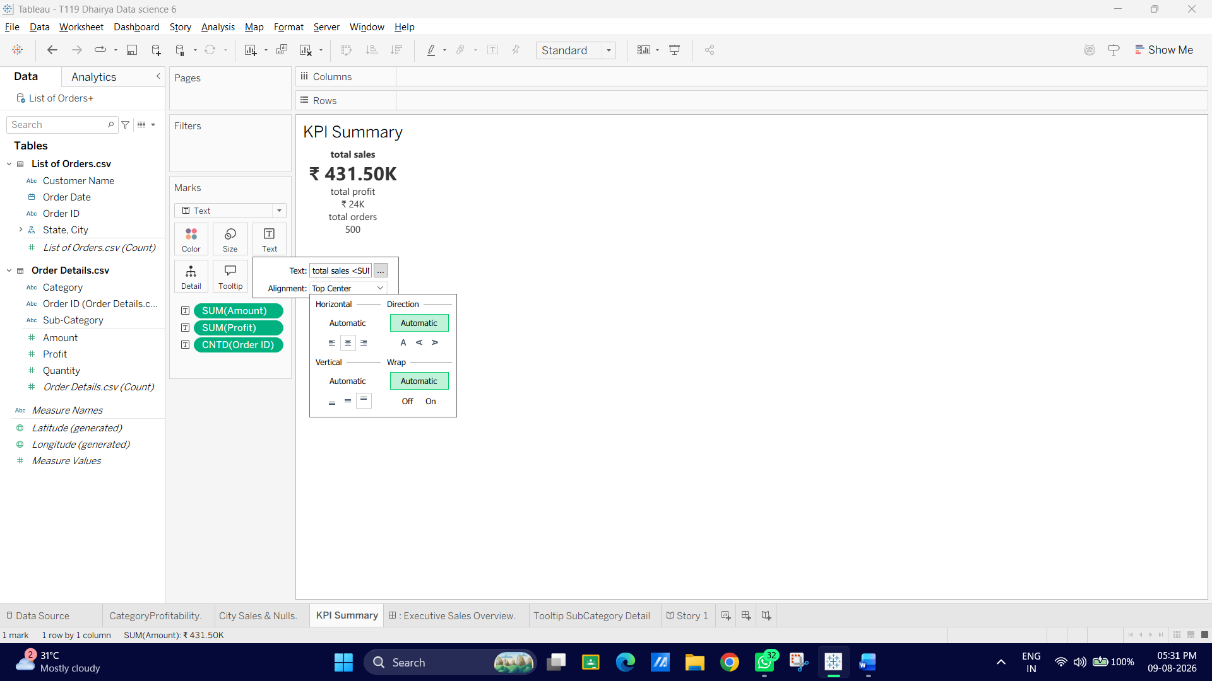
Task 3: Create a Dashboard Container Layout
1. At the bottom of the screen, click the New Dashboard icon (the icon with a grid).
2. Rename the dashboard tab: Executive Sales Overview.
3. In the Dashboard pane on the far left:
- Under Size, set the view to Fixed size or Desktop Browser (1000 x 800).
4. Under Objects at the bottom left:
- Ensure Tiled is selected.
- Drag a Vertical Container onto the blank dashboard canvas.

5. Drag your worksheets from the Sheets list into the container:
- Drag KPI Summary to the top section.
- Drag Category Profitability directly below KPI Summary.
- Drag City Sales & Nulls next to or below Category Profitability.
6. Click on the title of any sheet that isn't needed, right-click, and uncheck Title if you prefer a clean container header.
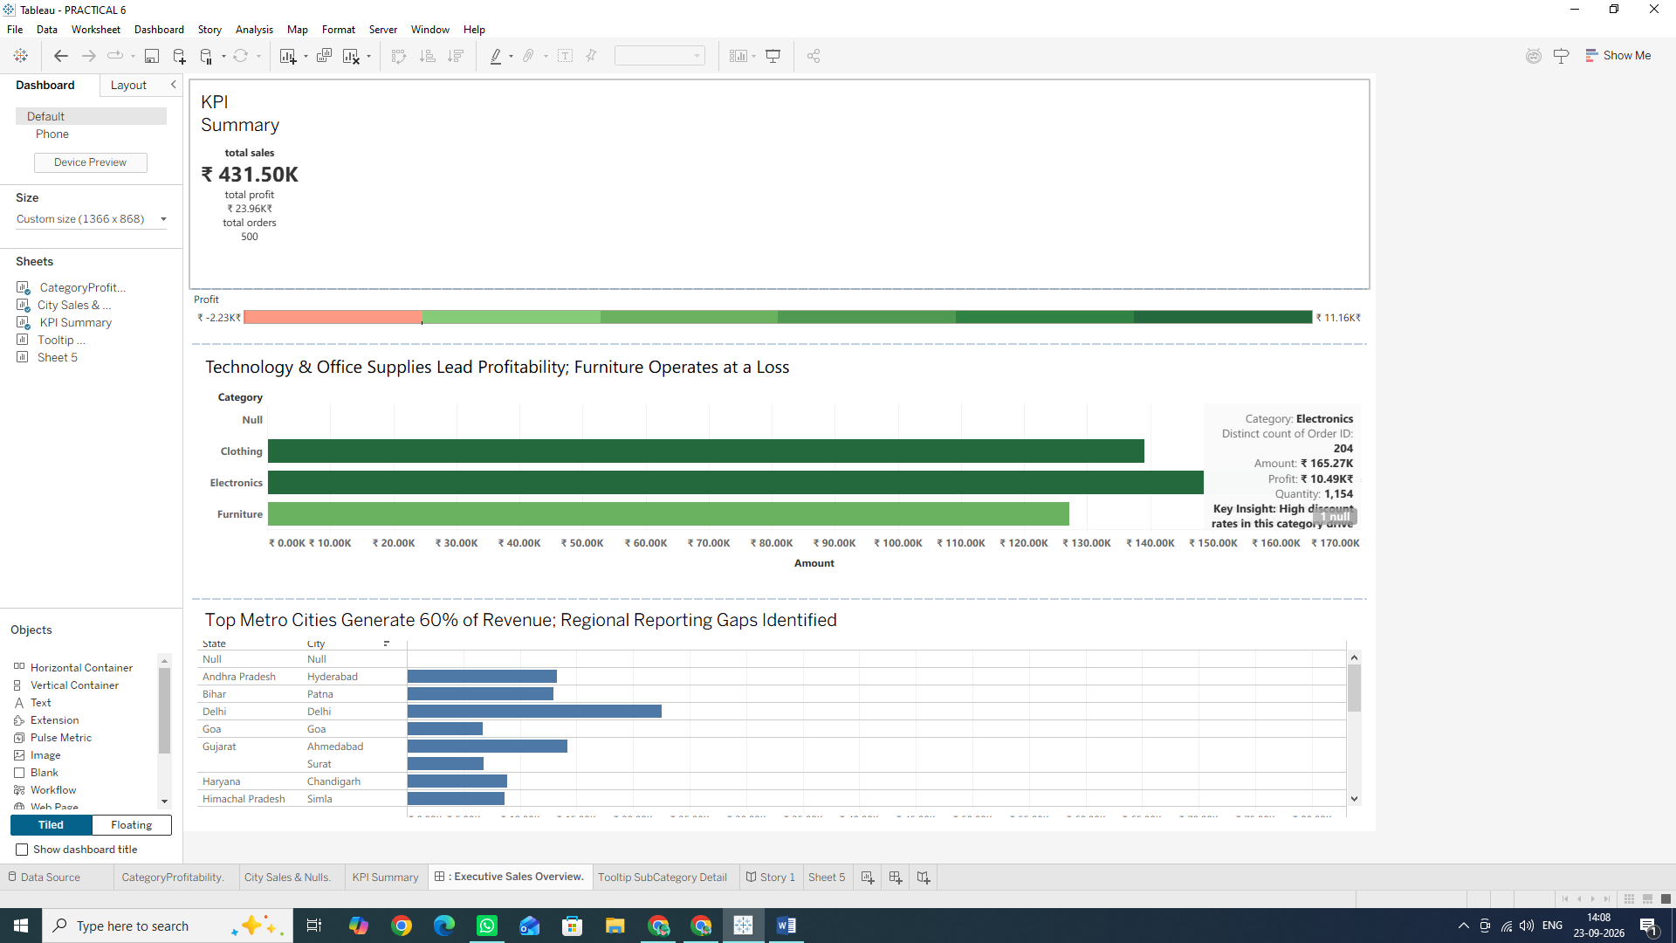
Why We Are Doing It ?
- Diverging Palettes Centered at Zero: Instantly highlights performance extremes (e.g., loss-making categories vs. highly profitable ones) without requiring users to read numbers line by line.
- KPI Cards & Containers: Structured dashboards use distinct sections and standardized KPI blocks at the top to give executive users an immediate high-level overview before they dive into detailed charts.

D: Create Informative Tooltips
Tooltips appear when a user hovers over any mark (bar, point, or cell) in a view. Default tooltips are often cluttered and show raw field names. Designing custom tooltips turns passive data popups into concise, sentence-based explanatory callouts.
Task 1: Open the Tooltip Editor
1. Click on your Category Profitability worksheet tab at the bottom.
2. On the Marks card (to the left of the chart), click the Tooltip card.
3. The Edit Tooltip dialog box will open showing the default Tableau code:
Category: <Category>, Profit: <SUM(Profit)>
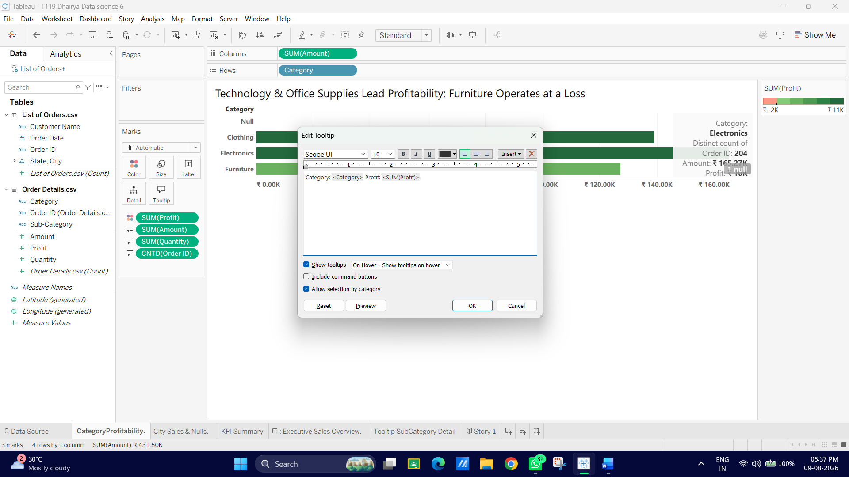
Task 2: Add Contextual Measures to the Tooltip
To make the tooltip truly informative, we need additional metrics available before writing the text:
- Click Cancel to temporarily close the Edit Tooltip window.
- From the Data Pane, drag Amount onto the Tooltip card on the Marks card.
- Drag Quantity onto the Tooltip card on the Marks card.
- Drag Order ID onto the Tooltip card, then click its drop-down arrow $\rightarrow$ Measure $\rightarrow$ Count (Distinct) so it displays as CNTD(Order ID).
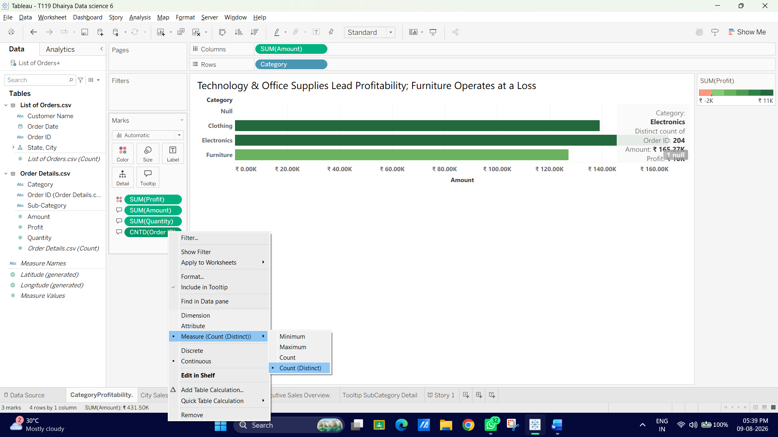
Task 3: Format the Tooltip into a Sentence-Based Story
1. Click the Tooltip card on the Marks card again to open the Edit Tooltip window.
2. Delete all existing text inside the box.
3. Re-type or paste the following clean, conversational text:
- Category Overview
- Generated <SUM(Amount)> in total sales across <CNTD (Order ID)> orders, selling <SUM(Quantity)> items. Net Profit: <SUM(Profit)>
4. Style the text for visual hierarchy:
- Highlight <Category> Category Overview: Make it Bold, size 12pt, and color Dark Blue/Navy.
- Highlight the sentence body: Set to Regular, size 10pt, and color Dark Gray.
- Highlight the metric dynamic tags (<SUM(Amount)>, <SUM(Profit)>, etc.): Make them Bold.
5. At the bottom left of the dialog box:
- Uncheck "Include command buttons" (This removes unnecessary selection buttons like Keep Only/Exclude to keep the interface clean).
- Check "Show tooltips: On hover".
6. Click OK.

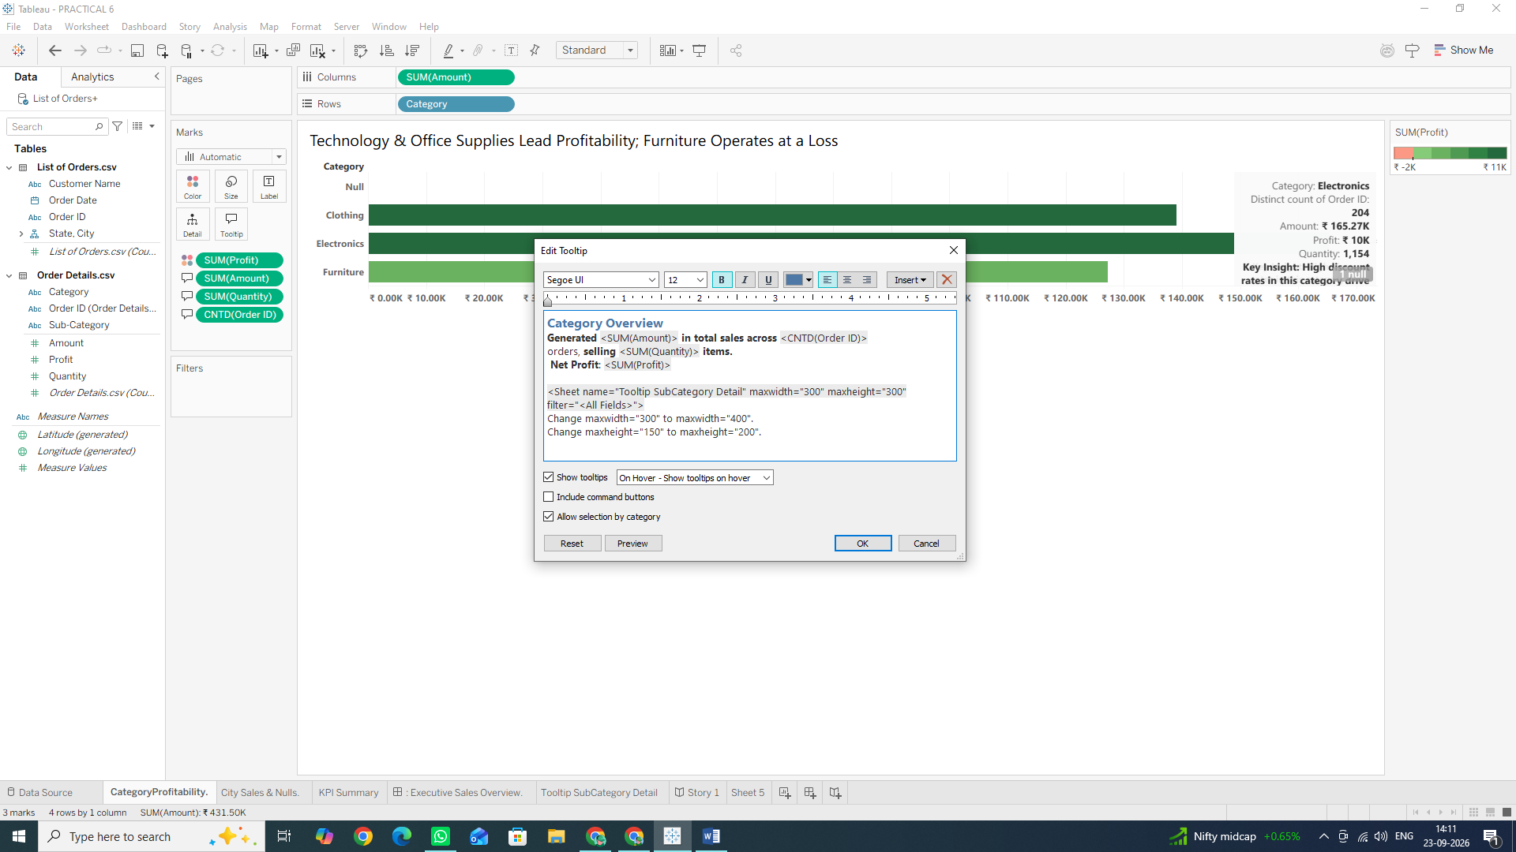
Task 4: Test Your Tooltip
1. Move your mouse cursor over any bar in the Category Profitability view.
2. Confirm that the popup reads as a clean, formatted sentence displaying exact sales, order counts, and net profit for that category!
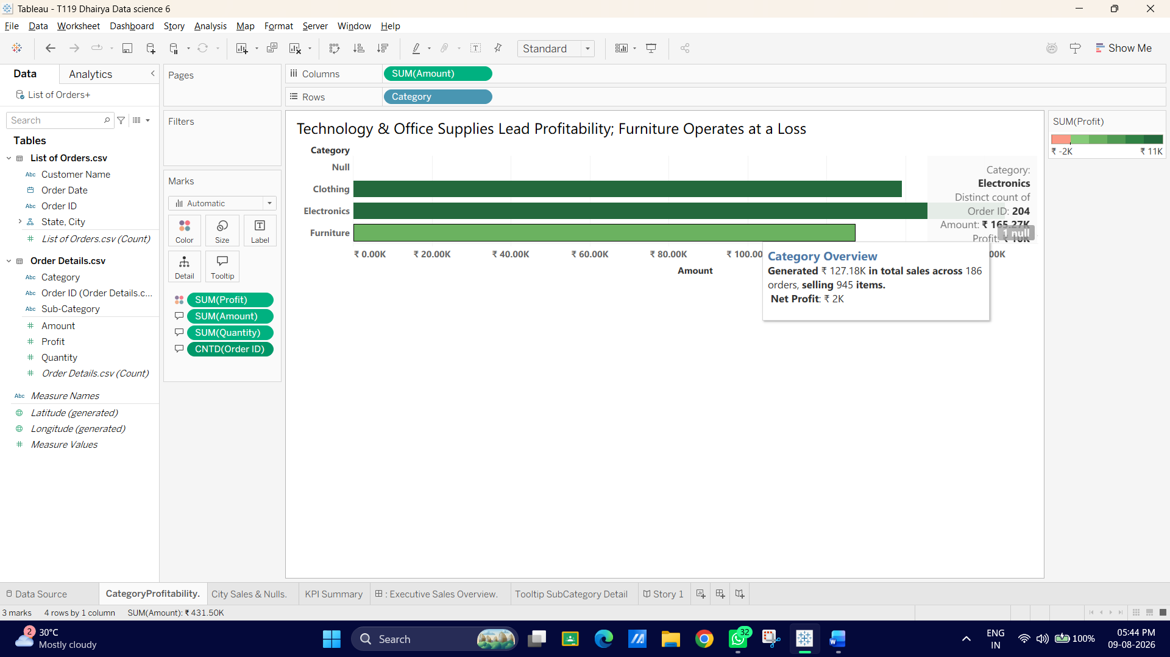

E: Implement "Viz in Tooltip"
Viz in Tooltip allows you to embed a secondary, detailed chart directly inside the tooltip of a primary chart. When a user hovers over a data point (like a product category), the embedded chart automatically filters to display deep-dive breakdown details (like individual subcategories or state performance) without cluttering the main dashboard.
Task 1: Build the Secondary Detailed Chart (Target Sheet)
First, create the chart that will live inside the tooltip.
1. Click the New Worksheet icon at the bottom of the screen and name it: Tooltip Sub Category Detail.
2. From the Data Pane, drag Sub-Category to the Rows shelf.\
3. Drag Profit to the Columns shelf.
4. Drag Profit to the Color card on the Marks card to give it visual context.
5. Sort the bars: Click the Sort Descending button on the top toolbar (or right-click sub-Category on Rows → Sort → Nested by Profit Descending).
6. Keep the sheet compact:
- In the top toolbar, change the view fit drop-down from Standard to Entire View.
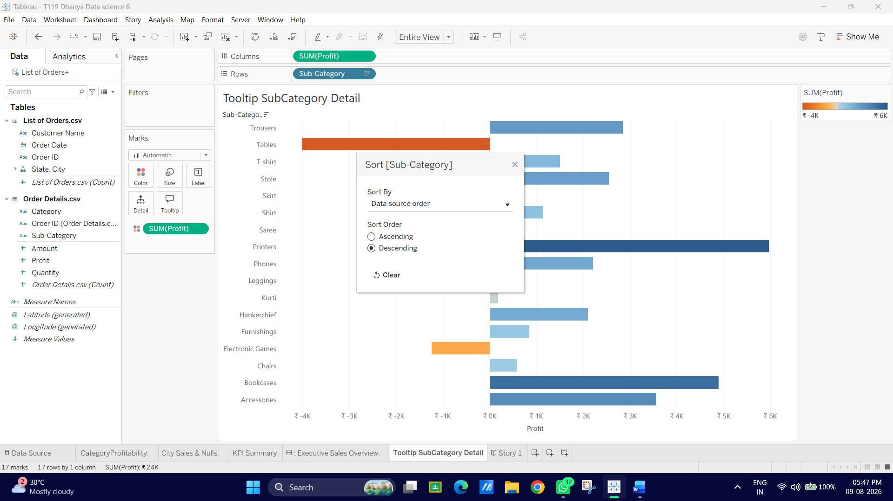

Task 2: Insert the Detailed View into the Main Chart's Tooltip
Now, link this secondary sheet into the main Category Profitability sheet.
1. Click on your primary worksheet tab at the bottom: Category Profitability.
2. On the Marks card, click the Tooltip card to open the Edit Tooltip window.
3. Place your cursor at the very bottom of your existing sentence-based text and press Enter to start a new line.
4. In the top right corner of the Edit Tooltip window, click the Insert drop-down menu.
5. Hover over Sheets, then click Tooltip SubCategory Detail.
6. Tableau will insert a tag that looks like this:
<Sheet name="Tooltip SubCategory Detail" maxwidth="300" maxheight="150" filter="<All Fields>">
7. Adjust the dimensions inside the tag if needed:
- Change maxwidth="300" to maxwidth="400".
- Change maxheight="150" to maxheight="200".
8. Click OK.
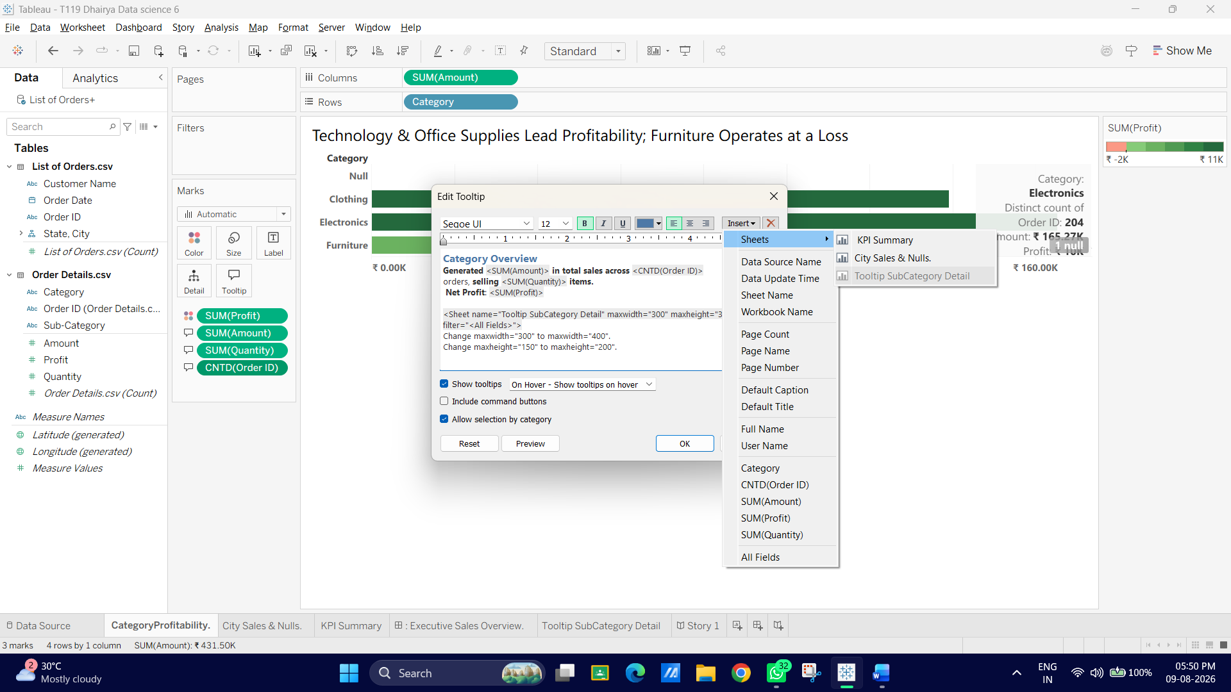

Task 3: Test and Verify the Interactive Filtering
1. Hover your mouse over one of the main bars (e.g., the Clothing or Furniture category bar) in your Category Profitability worksheet.
2. Observe the tooltip popup:
- It will show your sentence-based overview from Part D.
- Directly below the sentence, it will display a mini horizontal bar chart listing only the sub-categories that belong to that specific hovered category!
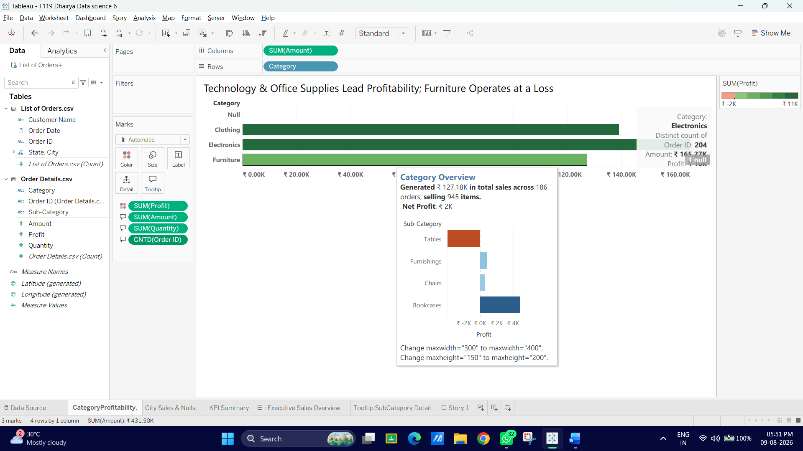
Why We Are Doing It ?
- Progressive Disclosure: Keeps high-level executive views clean while providing immediate, detailed breakdowns on demand without requiring additional dashboard space or extra click actions.
- Usage: Commonly used for showing sub-category breakdowns inside category views, month-over-month trend lines inside annual total bars, or regional state maps inside nationwide metrics.

F: Improve Readability and User Experience
In this final section, you will polish the dashboard for end users. You will refine layout spacing, add interactive highlight actions, clean up legends, and prepare the workbook for publication or sharing.
Task 1: Refine Dashboard Spacing and Padding
1. Switch to your Executive Sales Overview dashboard tab.
2. Click on the KPI Summary container/sheet to select it.
3. In the left-hand panel, click the Layout tab (next to the Dashboard tab).
4. Look for the Outer Padding and Inner Padding settings by scrolling:
- Click the lock icon to unlock all sides if needed.
- Adjust Outer Padding to 8 px on all sides to give space between the visual cards.
5. Click on the Category Profitability sheet and apply an Outer Padding of 8 px.
6. Repeat for City Sales & Nulls.

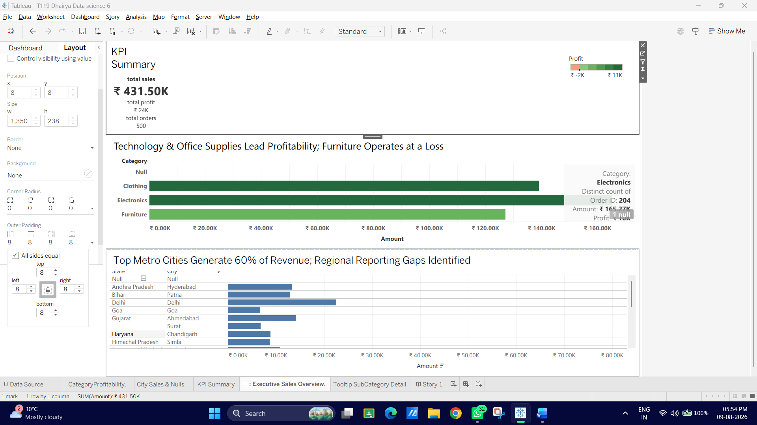

Task 2: Add an Interactive Highlight Action
1. On the top menu bar, go to Dashboard → Actions... (or press Ctrl + Shift + D / Cmd + Shift + D).
2. Click Add Action > at the bottom left and select Highlight...
3. In the Add Highlight Action window:
- Name: Type Highlight Category across Dashboard.
- Source Sheets: Select your dashboard name (Executive Sales Overview).
- Target Sheets: Check all worksheets listed under your dashboard.
- Run action on: Select Hover.
- Target Fields: Select Selected Fields → Click Category.
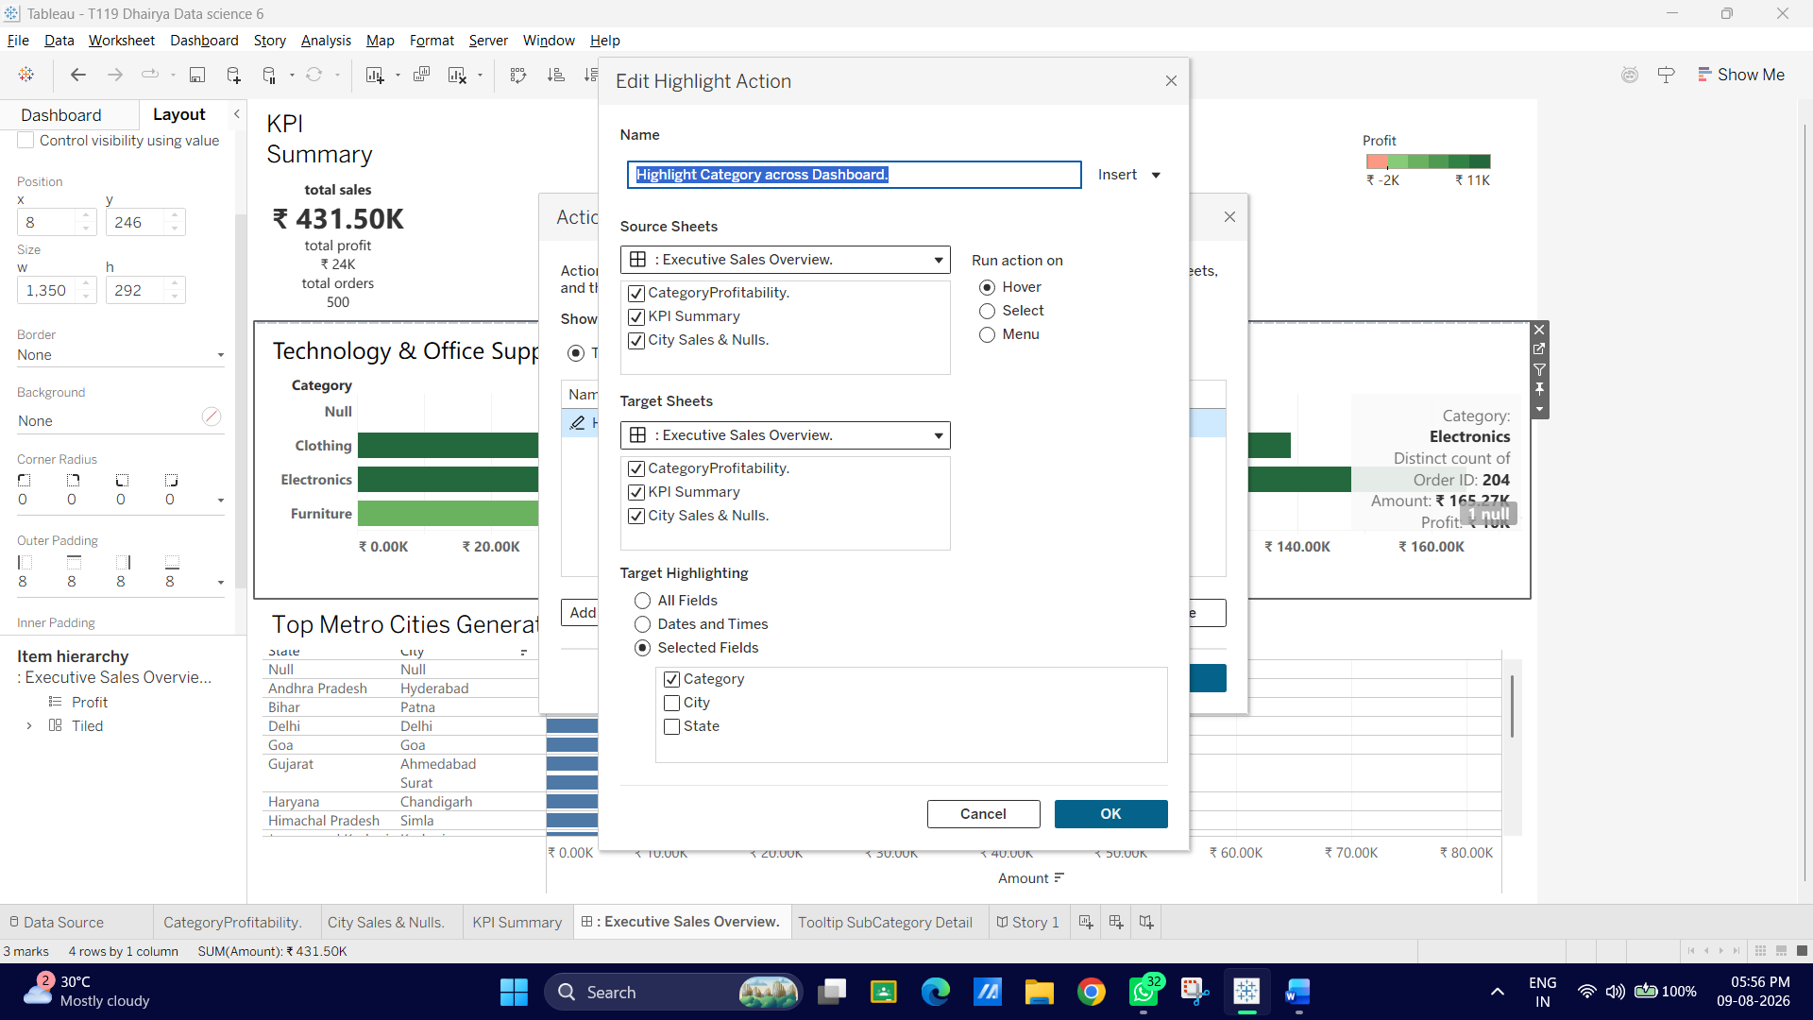
4. Click OK, then click OK again to save the action.
5. Test it: Hover over any category bar in the main view; matching categories across all other visible charts on the dashboard will highlight instantly while dimming non-relevant data.
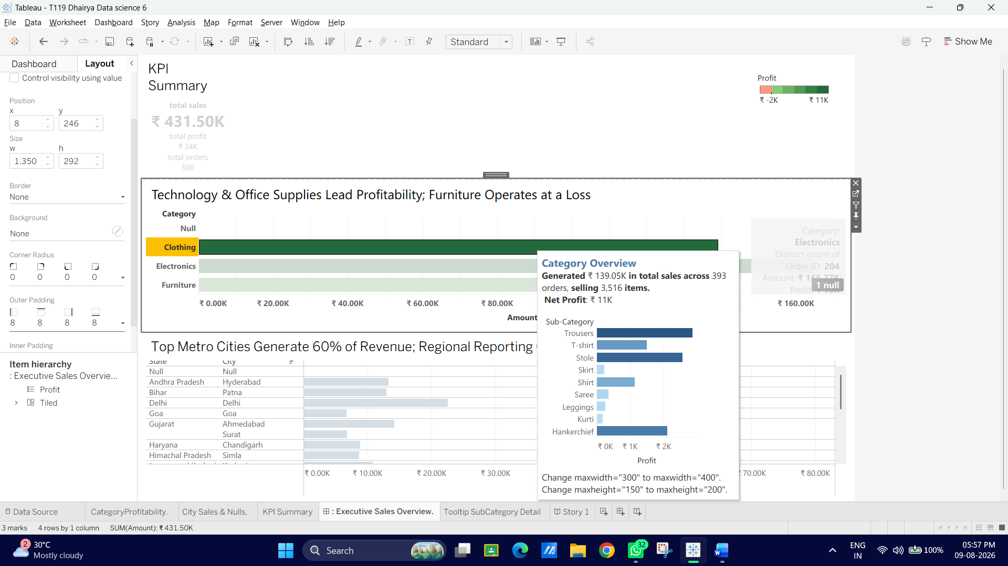
Task 3: Clean Up Color Legends and Floating Elements
1. Look at the right sidebar of your dashboard where color legends appear automatically.
2. Select any redundant or repetitive legend boxes (e.g., if Profit color legend is self-explanatory).
3. Click the X in the top right corner of the legend box to remove it, or convert critical legends into floating elements:
- Click the down arrow on the legend container box $\rightarrow$ select Floating.
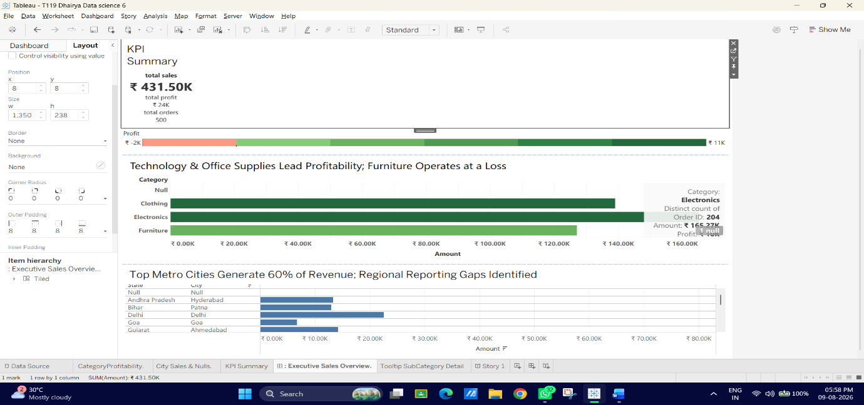
- Drag and position it neatly near the relevant chart so it doesn't take up full column width.
Task 4: Final Presentation Checks
1. At the bottom right of the screen (or in the top menu under Window), click Presentation Mode (or press F5).
2. Verify:
- Fonts are clean and consistent.
- Numbers display proper ₹ symbols with no awkward Null labels.
- Tooltips trigger seamlessly on hover with embedded sub-category breakdown charts.
- Highlighting functions smoothly across sheets.
3. Press Esc to exit Presentation Mode.
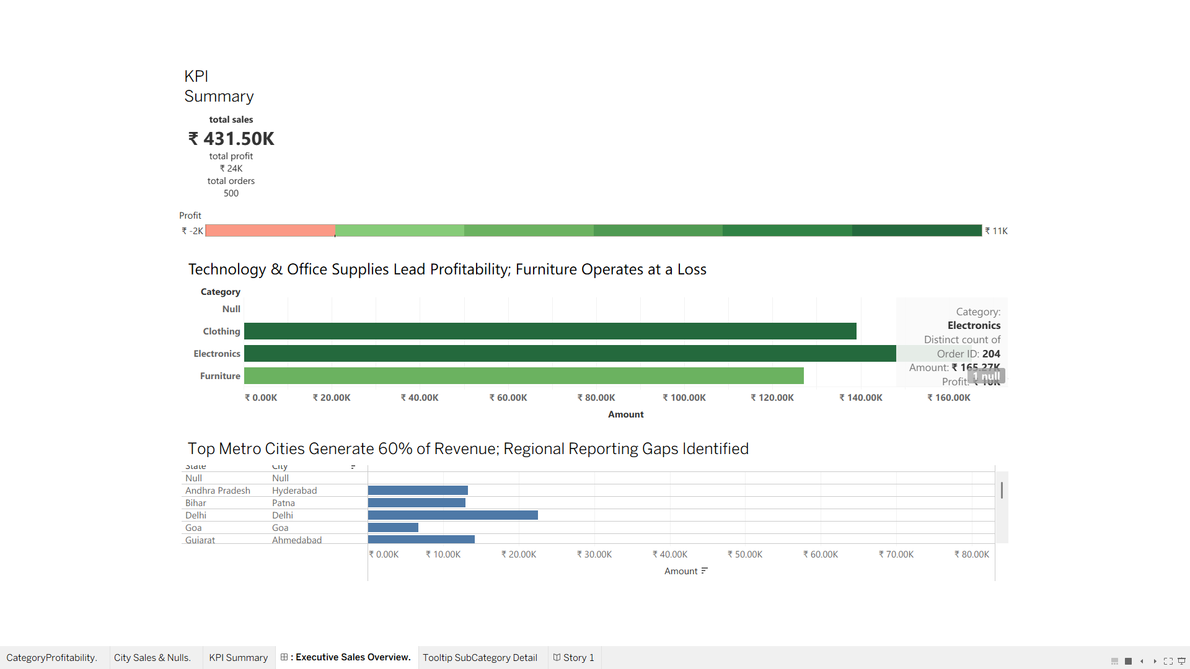
Why We Are Doing It ?
- Padding & White Space: Proper padding prevents visualizations from looking cramped and guides the viewer's eye across sections logically.
- Highlight Actions: Interactive highlighting lets stakeholders explore relationships across multiple charts without permanently filtering out background context.
- Streamlined Legends: Removing unnecessary clutter keeps the focus on key performance indicators and actionable business insights.

G: Apply Best Practices for Visual Storytelling
Visual storytelling transforms a static dashboard from a simple collection of charts into a clear narrative. In this final section, you will structure your dashboard around the F-shaped reading pattern, add action-oriented titles, use data callouts, and set up Tableau’s Story Points feature to guide stakeholders through a structured presentation.
Task 1: Re-structure Layout using the F-Pattern (Visual Hierarchy)
Eye-tracking studies show that dashboard readers scan content starting from top-left to top right, then down the left side.
1. Switch to your Executive Sales Overview dashboard tab.
2. Verify or adjust the sheet placement using a top-to-bottom reading path:
- Top Left: KPI Summary (Immediate baseline metrics: Total Sales, Total Profit, Orders).
- Middle Section: Category Profitability (Core narrative question: Which product categories drive or drag our profit?).
- Bottom/Right Section: City Sales & Nulls (Granular regional breakdown answering: Where are these sales geographically located?).
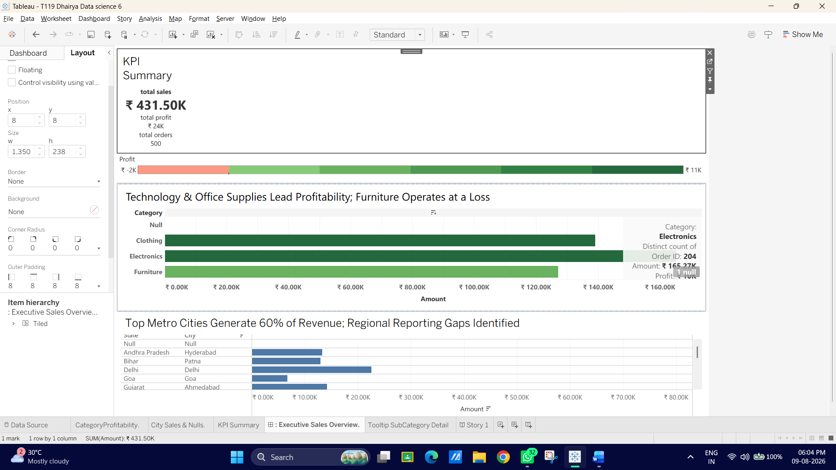

Task 2: Replace Descriptive Headers with Action-Oriented Insight Titles
Instead of naming a chart what it contains (e.g., "Category Profitability"), state what the chart reveals.
1. Double-click the title block of Category Profitability on your dashboard.
2. Edit the title text to be insight-driven:
- Change from: Category Profitability
- Change to: Technology & Office Supplies Lead Profitability; Furniture Operates at a Loss
3. Double-click the title block of City Sales & Nulls.
4. Edit the title text:
- Change from: City Sales & Nulls
- Change to: Top Metro Cities Generate 60% of Revenue; Regional Reporting Gaps Identified
5. Click OK.
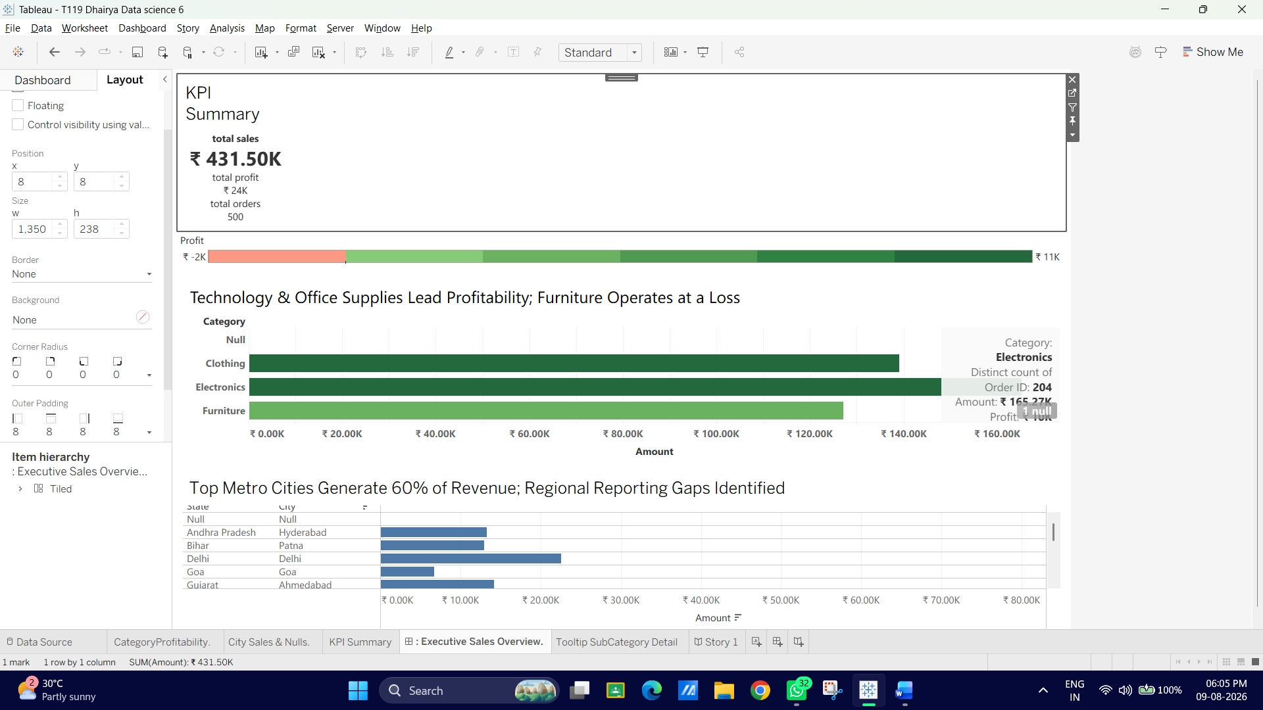

Task 3: Add Direct Data Annotations for Significant Points
Annotations draw immediate focus to key anomalies or inflection points directly on the chart canvas.
1. Right-click on the bar with the lowest profit (or highest loss) in your Category Profitability sheet.
2. Hover over Annotate $\rightarrow$ select Mark...
3. In the annotation window, write a brief explanatory callout:
Key Insight: High discount rates in this category drive negative margins.
4. Format the text to 9pt, Dark Gray, Bold, then click OK.
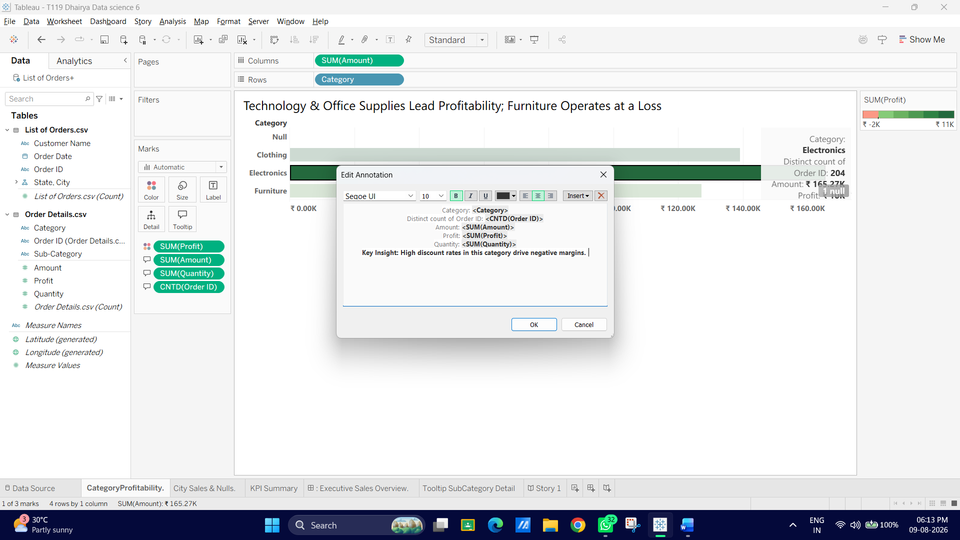
5. Drag the line callout box so it sits cleanly above or next to the bar without overlapping neighbouring data.
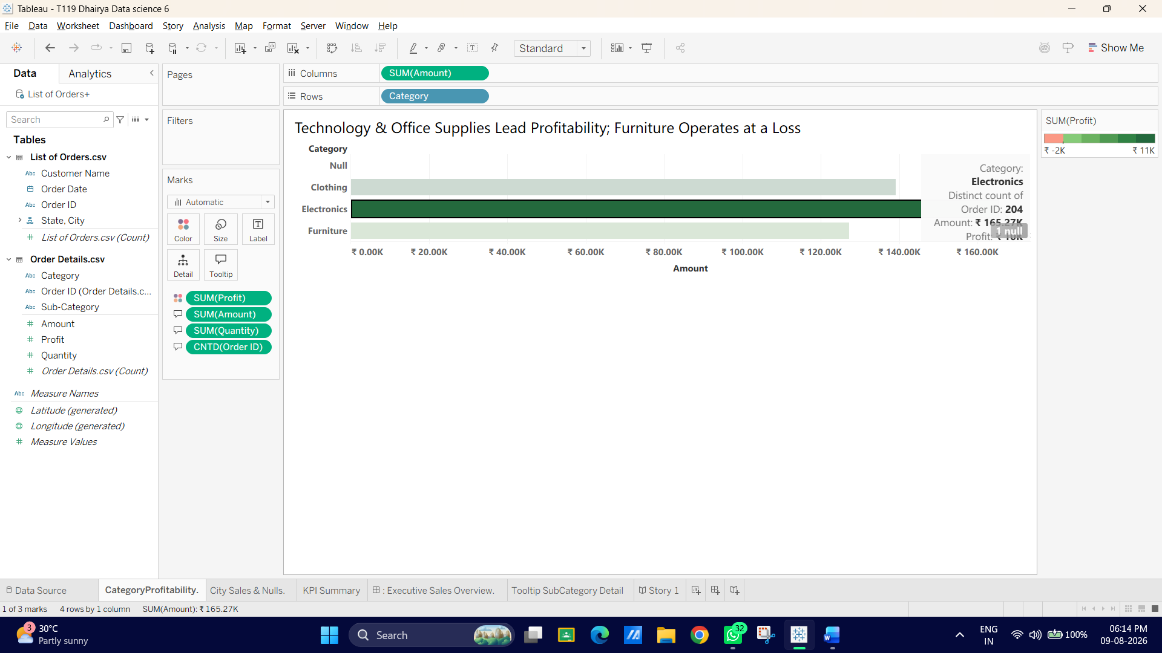
Task 4: Build a Guided Story Sequence (Tableau Story Points)
Story Points allow you to sequence multiple dashboard states or views into interactive "slides" with narrative captions.
1. At the bottom of your Tableau window, click the New Story icon (the book icon next to New Dashboard).
2. Name the story tab: E-Commerce Executive Presentation.
3. In the left-hand Story Pane, drag your Executive Sales Overview dashboard onto the canvas.
4. Click on the gray navigation box above the view (the "Story Point" caption box) and type your first story point heading:
1. Executive Summary: Sales remain strong across top categories, reaching target revenue.
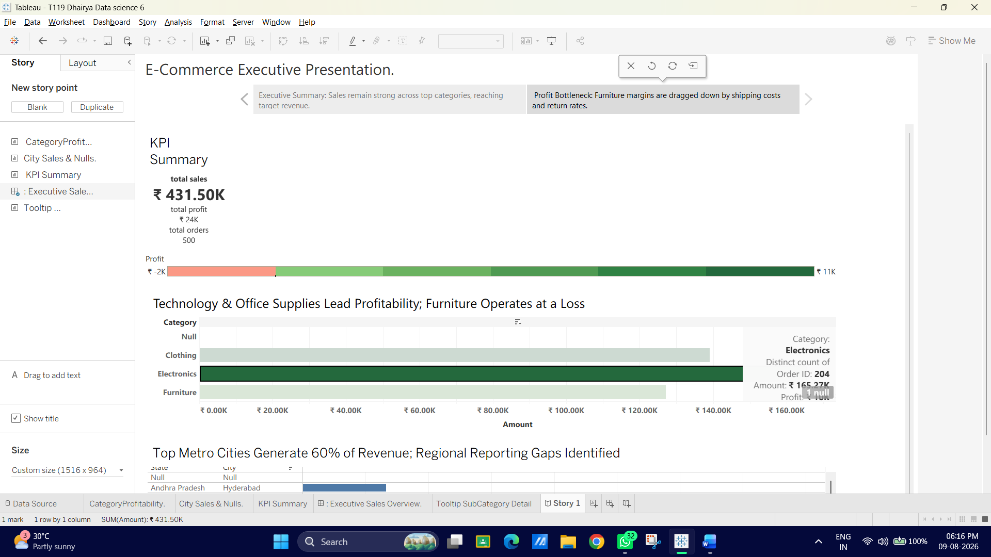
5. In the top-left pane, click Blank under New Story Point to add a second slide.
6. Drag Executive Sales Overview onto the canvas again.
7. On the dashboard view itself, click on the Furniture category bar (or lowest profit bar) to filter/highlight it across the entire screen.
8. Click the caption box for Slide 2 and type:
2. Profit Bottleneck: Furniture margins are dragged down by shipping costs and return rates.
